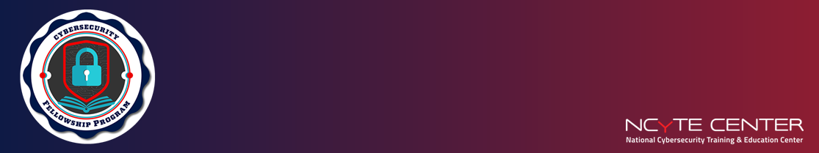
National Community College Cybersecurity Fellowship Program
Fellowship Fellow Agreement
Thank you for participating in the NCyTE Faculty Fellowship Program. This agreement outlines your responsibilities as a Fellow and the required deliverables to complete your teaching assignment. The goal of this experience is to support your professional development as an emerging cybersecurity educator through guided mentorship and real-world instructional practice. Completion of the responsibilities and submission of the required deliverables listed below is required for stipend eligibility.

Fellow Responsibilities
As a Fellow, I understand that I am expected to:
- Collaborate with an assigned Faculty Mentor to identify a lesson topic and complete the Statement of Work (SOW)
- Meet regularly with my mentor to plan and reflect on my teaching assignment
- Design and deliver a lesson on a cybersecurity-related topic (in-person or remote)
- Develop a lesson plan using UDL, Backward Design, and active learning strategies
- Create a supporting slide deck and a hands-on activity or demonstration
- Include an assessment tool (e.g., quiz, rubric, or reflection)
- Upload a complete and organized module
- Contribute at least 60 hours toward the teaching assignment
- Reflect on my experience and respond to feedback from my mentor

Fellow Deliverables
I must complete and submit the following:
- A fully signed Statement of Work
- A complete module including lesson materials, assessment, and activity files
- A recording (or confirmation) of at least one delivered class session
- A completed Fellow Self-Reflection Form
- Submit all required deliverables via email
Note: Fellows are not responsible for grading, conducting research, or completing unrelated teaching tasks. These activities are optional and not counted toward the assignment.

Stipend Eligibility Requirements
To be eligible for the stipend, I understand that I must:
- Fulfill the Fellow responsibilities and submit all deliverables by September 10, 2026 **
- Complete NCyTE’s Post-Teaching Evaluation Survey by September 10, 2026**
- Notify NCyTE if your address has changed since you last submitted a W9, so we can send you an updated form to complete.

**Note: To ensure sufficient time for processing before the grant ends on September 10, 2026, all program deliverables, including the survey, must be submitted by September 10, 2026. Deliverables submitted after this date will not be eligible for stipend payment.

Acknowledgement and Agreement
By signing below, I acknowledge that I have read, understood, and agree to the responsibilities, deliverables, and stipend eligibility requirements. I agree to fulfill all expectations as a Fellow in the NCyTE Faculty Fellowship Program.

Fellow Name (print)
Fellow Signature
Date
Faculty Mentor Name
Institution

