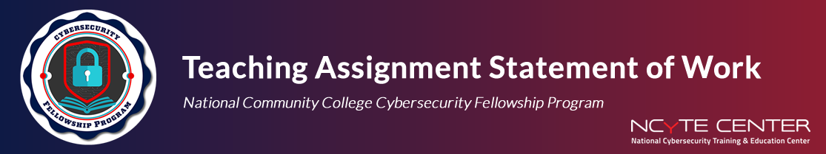

This Statement of Work outlines the specific teaching assignment for the NCyTE Faculty Fellowship Program. It serves to document the agreed-upon scope, timeline, and deliverables that must be completed by the Fellow with the support of the assigned Faculty Mentor.

Fellow
Faculty Mentor
Faculty Mentor Email
Institution
Course Title
Canvas Course URL

Statement of Work
Please complete a Statement of Work that includes the following information (you may add additional details as needed):
- Subject / Topic: Specify the cybersecurity topic your lesson will cover.
- Learning Outcomes: List 3–5 specific and measurable learning objectives that align with the course.
- Modality: Indicate how the lesson will be delivered (e.g., in-person, remote synchronous/ asynchronous).
- Due Date: Provide the final due date for submitting all deliverables and completing the teaching assignment

Lesson Topic
Learning Outcomes
Modality
Scheduled Delivery Date
Due Date

Required Deliverables

The Fellow will provide the following items:
- Lesson Objectives: Clearly defined goals and learning outcomes
- Slide Deck: Title, objectives, instructional content, and summary
- Hands-on activity or demonstration.
- Lecture Recording: Submit a recording of the lecture
- Supplemental Resources: Articles, videos, or handouts that support the lesson
- Assessments: Aligned quizzes or assignments measuring learning objectives

Additional Notes

Use this space to outline any additional expectations or requirements.

Statement of Work Acknowledgement & Sign-Off

By signing below, both parties agree to the scope of work and deliverables outlined in this Statement of Work.

Fellow Name (print)
Fellow Signature
Date
Faculty Mentor Name
Faculty Mentor Signature
Date

