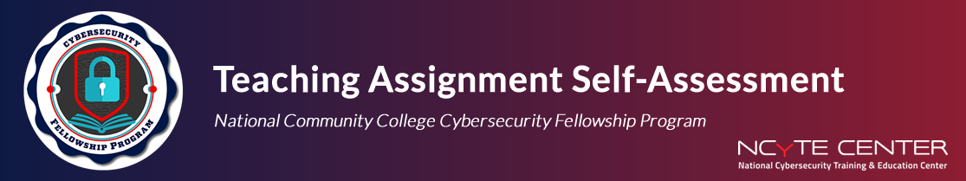
This form is designed to help you reflect on your teaching experience. Your honest reflection will support your growth as an instructor and help us improve the fellowship experience.

Fellow
Faculty Mentor
Course Taught
Date of Lesson
Lesson Topic

Self-Reflection Questions

- What were the 3–5 learning objectives for your lesson, and how well do you think you met them?

- What aspects of your lesson planning and preparation went well?

- What challenges did you face while preparing or delivering your lesson?

- How did students respond to your lesson (if applicable)?

- What feedback did you receive from your mentor, and how did it impact your reflection?

- If you could teach this lesson again, what would you do differently?

- What did this teaching experience reveal about your strengths and areas for growth as a future educator?

- How has this experience influenced your interest in teaching at the community college level?

Optional Testimonial: If you'd like to share a brief testimonial about your experience as a Fellow, please enter it below. By providing a testimonial, you grant NCyTE permission to use it in future publications (e.g., newsletters, reports, or websites). If you prefer your testimonial to be shared anonymously, please indicate that in your response.

